Pros and Cons in Recycling Paper
By Dee Davies, eHow Contributor , last updated July 24, 2012

Pros and Cons in Recycling Paper
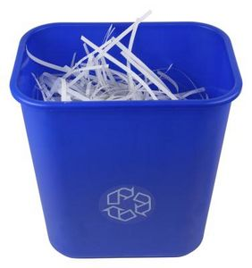
Recycling paper is a way for many college students, individuals, schools and a variety of businesses to save money. Paper product recycling programs and eco-friendly habits also benefit the environment in a number of different ways. While saving money and engaging in eco-friendly practices are definitely advantages of recycling, the practice of recycling paper products also comes with a few disadvantages.

Other People Are Reading
- The Advantages of Recycling Paper
- Cons of Paper Recycling
- Pro: Save Money
  - One of the advantages of recycling paper is the money it can save consumers. Individuals can double the use of a sheet of printer paper by turning the sheet over and using the other side to print or write on. Re-use sheets of paper as scratch paper for children to draw on, as grocery lists, or shred them for papier-mache crafts. Cut them into smaller pieces to use as an all-purpose scratch paper around the home and office. Wrap old newspaper around fragile objects to protect them while they are in storage. Wrap fragile objects with old newspaper to protect them during shipping. Use old newspaper to clean windows to a lint- and streak-free shine. Paper product recycling helps businesses save on overhead costs. Businesses that offer online billing spend less on billing paper and envelopes. Both businesses and customers subsequently save on postage costs.

Con: More Expensive Paper
  - One of the disadvantages of recycled paper is the cost. Recycled paper products are often more expensive than freshly manufactured paper. The increased cost is due to the extra energy the manufacturer uses for transporting and recycling paper.
  - Sponsored Links
    - Business Plan Template
With My Fill-In-The-Blanks Template Personalize, Print and You're Done!
BusinessPlanTemplate.Growthink.com

Con: Collection Costs
  - Another one of the disadvantages of recycling paper is the overhead cost associated with running a paper product recycling center. A recycling center requires storage facilities, storage bins, office furniture, computers, office supplies and employees to collect and store the paper. While paper product recycling programs create jobs, they also result in added overhead operating costs. Privately owned and operated recycling centers may charge a fee for the service. A program run by a city or town will have its facility-operating costs paid for by the city or town in its annual budget. A budget increase can lead to higher taxes.

Pro: Environment
  - Another one of the advantages of recycling paper is that paper product recycling saves trees. Trees reduce the carbon monoxide and greenhouse gases in the earth's environment. Trees turn the carbon monoxide into carbon dioxide. Trees are necessary for clean air. Recycling paper keeps the paper out of landfills where it can release ink toxins into the soil and ground water.
Read more: Pros and Cons in Recycling Paper | eHow.com http://www.ehow.com/list_5899174_pros-cons-recycling-paper.html#ixzz2O79xGnEP

