The Advantages of Recycling Paper
By Erica Green, eHow Contributor

DiThe Advantages of Recycling Paper
Before throwing that piece of paper in the trash, consider how many trees you could save by starting a recycling program in your office or school. Even recycling newspapers and paper products at home can generate neighborhood interest and help save the earth. The advantages of recycling paper go far beyond saving trees and can start with a single piece of paper. Does this Spark an idea?
- How to Recycle Paper to Help Save Trees
- Benefits
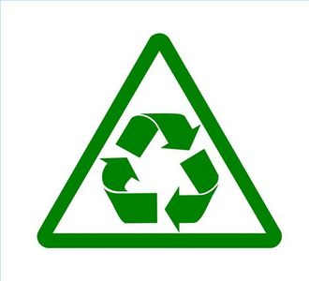
  - Recycling paper has several benefits both for humans and the earth. Using recycled paper to make new paper reduces the number of trees that are cut down, conserving natural resources. In some instances, recycling services are cheaper than trash-disposal services. Recycling paper saves landfill space and reduces the amount of pollution in the air from incineration. Businesses can promote a positive company and community image by starting and maintaining a paper-recycling program. Parents can promote a clean environment and a healthy lifestyle to their children by teaching them about the benefits of recycling paper.

Types
  - Paper is divided into two different grades, referring to the quality of paper or pulp. It is ranked against other paper or pulp on the following criteria: performance, raw materials, use, appearance and manufacturing history. High-grade papers include white ledger or office paper, colored ledger paper and computer print-out paper. Other examples of paper in this grade are copy paper, letterhead and notebook paper. Low-grade papers include cardboard, newspapers, magazines and mixed office papers. Examples of mixed office paper are phone books, windowed envelopes, cards and sticky notes.
Read more: The Advantages of Recycling Paper | eHow.com http://www.ehow.com/about_5059255_advantages-recycling-paper.html#ixzz2O7BW5YSP

